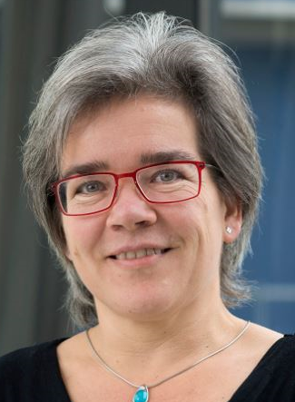

Marie-José Goumans received her PhD degree in cardiovascular development from Utrecht University. She did her postgraduate studies with Peter ten Dijke at the Ludwig Institute for Cancer Research in Uppsala, Sweden, and the Netherlands Cancer Institute, Amsterdam. In 2003, she initiate studies on cardiac progenitor cells in heart regeneration at the department of cardiology, Utrecht UMC, and received a prestigious VIDI grant in 2004. In 2008, she continued her studies on TGF beta signaling and cardiovascular regeneration at the LUMC. In 2009, she became a member of the Young Academy of the KNAW. From February 2012, she was appointed professor of molecular cardiovascular cell biology at Leiden University.

Goumans’ lab:
Babu Kurakula: https://ccb.lumc.nl/research/konda-babu-kurakula-212
Tiago Guimaraes Ferraz: https://ccb.lumc.nl/research/tiago-guimaraes-ferraz-222

